|  |
| --- |
| Big Mountain Resort Price Analysis Report |
|  |  |  |
| Submitted by: Aditi Gupta, Dec 2023 |

# Introduction

Big Mountain Resort is a popular ski resort located in Whitefish, Montana. The resort

offers fantastic views of the Flathead National Forest and Glacier National Park in addition to several different types of ski-runs. Its services include 11 lifts, 2-T bars, and 1 magic carpet for novice skiers. The base elevation is 4,464 feet, the summit is 6,817 feet, and the longest run is 3.3 miles in length. Big Mountain Resort has recently installed a new chair lift to increase visitors’ distribution across the mountain. This has increased their operating costs by $1.54 million this season. This new cost has caused the business to rethink their pricing strategy, which was previously to charge a slight premium above the average price of resorts in its market segment.

# Problem Statement

Optimize the usage of Big Mountain Resort's facilities to offset a $1.6 million rise in operating costs through adjustments in pricing strategies for the current season. Leverage these findings to enhance revenue in the upcoming season.

# Data Wrangling

Our dataset includes several important values like the total vertical drop, number of lift chairs, weekday/weekend price, and total number of runs for each resort. For modelling the ticket price, we have to check the relationship between adultweekday and adultweekend ticket prices. We plotted a scatterplot to visually compare them and find out that there is a clear line where adultweekday and adultweekend prices are equal. Weekend prices being higher than weekday prices seem to be restricted to sub $100 resorts. Our target resort is in Montana and according to our data, both prices seem to be equal there. So, particularly for this state, the difference in price seems to be irrelevant. As weekday prices have more missing values compared to two, we drop the entire column.A graph with blue dots

In addition to AdultWeekend, the fastEight column

was dropped because the value of its values were nulls, and the other half were mostly 0.

Besides those two big ones, there were some smaller columns that had to be dropped and

a lot of missing values that had to be taken care of. Once this was finished, we were left with 277 of the original 330 rows.

# Exploratory data Analysis

To capture relevant state data related to our interests, we combine the ski resort data with state summaries, focusing on resort-related factors (used Principal Component Analysis (PCA)). We create a heatmap to understand correlations between different aspects. We see strong connections between summit and base elevation and some positive correlation between night skiing area and resorts per capita. Looking at our main interest, the "AdultWeekend" ticket price, we notice correlations with features like fastQuads, Runs, SnowMaking_ac, total_chairs, and vertical drop. Among the new factors, the ratio of night skiing area per state seems most connected to ticket prices. Now we can use these features to build a model that can determine a new data-based ticket price.

Correlations might hide relationships between variables, so we create scatterplots to explore ticket price variations with other features. We see strong positive connections with vertical drop and other factors like fastQuads, Runs, and total_chairs. The feature "resorts_per_100kcapita" shows that ticket prices can vary widely but tend to rise as the number of resorts per person increases. Higher ticket prices in areas with fewer resorts might indicate a monopoly effect where fewer resorts cater to a higher demand.

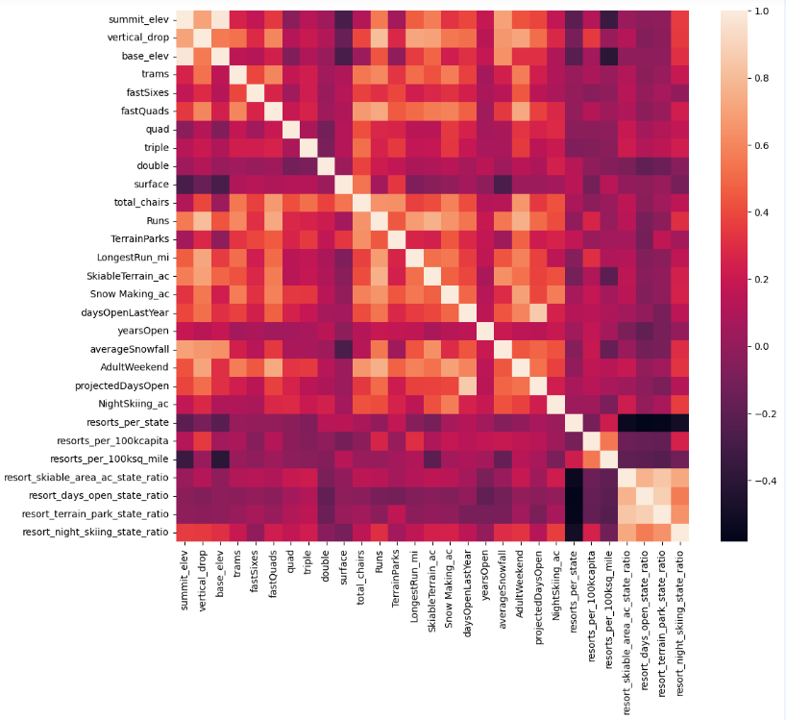

# Preprocessing and Training

After identifying the four categories with the strongest correlation to price, the first step

was to take an initial average as a “best guess” for pricing. Mean wasn’t the best for this because our Absolute Error was off by around $19, much too large for a

price like this. Instead, we performed a regression using the median between results. The

Mean Absolute Error was only off by $9 this time, but we knew this could still be improved. We

also decided to create a data pipeline to efficiently produce identical results to

make comparisons easier. The next regression was based on a Random Forest Model

which helped identify that imputing the median value helps with the MAE of our four components. In addition to our four components, during the analysis we found that vertical drop also plays a big role in determining ticket prices. Here we build and evaluated two modeling approaches, linear regression vs. random forest regression, and found that the later performs better, having less mean error and exhibits less variability.

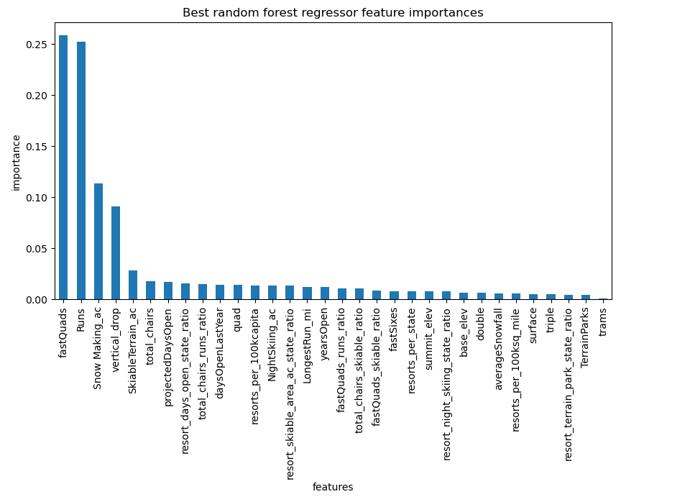

# modelling

Using Random Forest regression, Big Mountain Resort modelled price is $95.87, actual price is $81.00. Even with the expected mean absolute error of $10.39, this suggests there is room for an increase. To determine a fair price, we needed to see where Big Mountain Resort (represented by the dashed red line) ranked in the categories below.

|  |  |
| --- | --- |
| Vertical Drop |  |
| Total Chairs |  |
| Fast Quads |  |
| Longest Run |  |
| Number of Trams |  |
| Number of Runs |  |
| Area Covered by Snow Makers |  |
| Skiable Area |  |

Big Mountain Resort has been reviewing potential scenarios for either cutting costs or increasing revenue (from ticket prices). Ticket price is not determined by any set of parameters; the resort is free to set whatever price it likes. However, the resort operates within a market where people pay more for certain facilities, and less for others. Being able to sense how facilities support a given ticket price is valuable business intelligence. This is where the utility of our model comes in.

The business has shortlisted some options:

1. Permanently closing upto 10 of the least used runs. This doesn't impact any other resort statistics.
   1. The model says closing one run makes no difference. Closing 2 and 3 successively reduces support for ticket price and so revenue. If Big Mountain closes down 3 runs, it seems they may as well close down 4 or 5 as there's no further loss in ticket price. Increasing the closures to 6 or more leads to a large drop.

1. Increase the vertical drop by adding a run to a point 150 feet lower down but requiring the installation of an additional chair lift to bring skiers back up, without additional snow making coverage.
   1. This scenario increases support for ticket price by $1.99. Over the season, this could be expected to amount to $3474638.
2. Same as number 2 but adding 2 acres of snow making cover.
   1. This scenario increases support for ticket price by $1.99. Over the season, this could be expected to amount to $3474638. Such a small increase in the snow making area makes no difference!
3. Increase the longest run by 0.2 mile to boast 3.5 miles length, requiring an additional snow making coverage of 4 acres.
   1. No difference whatsoever. Although the longest run feature was used in the linear model, the random forest model (the one we chose because of its better performance) only has longest runway down in the feature importance list.

# Conclusion

One-day adult ticket is currently priced at $81 if 350,000 average visitors ski for 5 days in the upcoming season, the prediction is for a $3.47M increase in revenue if the ticket price is raised by $1.99. This increase is based on adding a run 150 feet lower down and installing a chair lift to accommodate it.

However, the model does not include the additional costs for the capital expenditure or ongoing operations, as this data hasn't been provided. It's assumed that adding the chair lift would raise operating costs by $1.54 million.

Additionally, closing the least used run is anticipated to have no impact on the current revenue. But closing between 2 to 5 successive least used runs could weaken support for the current ticket price.

# Future scope of work

The price prediction model suggests the potential to increase the price above $83 (possibly even higher). However, doing so would require further improvements to the facility to support this price increase. The resort is already positioned as a high-end option in the market and is competitively priced compared to similar resorts offering comparable amenities. Given Big Mountain's geographical advantage in competing within the premium market, enhancing the facility to attract more visitors while charging a higher price would strengthen the resort's competitive edge, especially during a prosperous market phase.

To enhance the model, the next steps involve incorporating (1) operational cost and other facilities data and (2) visitor volume across the U.S. It's also important to survey the market to understand the willingness of customers to pay a premium based on different amenities and features.

Additionally, it's advisable to involve a diverse team of business experts to test the model and challenge the business assumptions. To make the model more accessible, consider packaging it into an API that can be easily used either directly from a spreadsheet or embedded and accessed through an interactive dashboard available via the company's intranet.